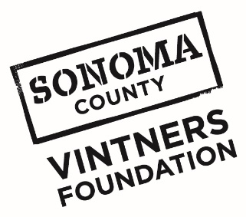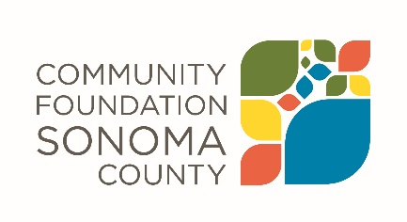
Sonoma County Vintners Foundation
Community Grants
2019-2020

Final Report Template

Sonoma County Vintners Foundation is interested in the impact our grant award has made on your organization and the community you serve. The grant report provides a structured process for reflecting on your work and a vehicle for describing impact to the community.
Report Instructions
Email your completed report as an attachment to grants@sonomacf.org no later than July 31, 2020. Please refer any questions to Annette Williams, Program Coordinator, Community Foundation Sonoma County, awilliams@sonomacf.org, 707-303-9639.
Please complete the lines below.
Grantee Organization Name:
Grant Number and Grant Amount:
Period Covered by this Report:
Organization Contact Person and Phone Number:
Date Report is Submitted:

Due to COVID-19, the final report has been streamlined to only capture essential information. Please respond to the following.

- Please concisely describe whether or not you were able to meet your program goals as funded by this grant. If the program was disrupted by COVID-19, please indicate that in your answer.

- Did your organization use remaining funds for general operating support? Yes / No (circle one)

- If yes, how much was used for general operating support?

