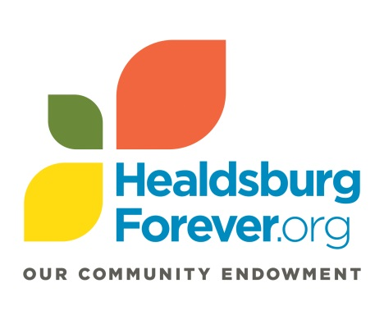
Healdsburg Forever is interested in the impact our grant award has made on your organization and the community you serve. The grant report provides a structured process for reflecting on your work and a vehicle for describing impact to the community.
Report Instructions
Deadline for submission is January 7, 2020. Please email your completed report as an attachment to Annette Williams, Programs Coordinator, awilliams@sonomacf.org. It is helpful to have a copy of the original Grant Application and Grant Contract on hand when drafting your responses.
2018-2019 Healdsburg Forever Grant Report
Grantee Organization Name:
Grant Number and Grant Amount:
Period Covered by this Report: 12/1/18 – 11/30/19
Organization Contact Person and Phone Number:
Date: (give the date the report is submitted)
Please respond to the following. Refer to the Grant Application when answering specific questions about the program for which you applied. (Keep answers to no more than 200 words)
- Please describe specifically the goals you aimed to accomplish with support from this grant. This information should come directly from your original proposal.

- What progress was made toward realizing these goals? If possible, discuss evidence of impact, e.g., number of clients served, demographic information, evaluation results, etc.

- Please describe the processes by which you evaluate the success and impact of your program.

- Please describe any unanticipated results, either positive or negative, in implementing the program.

- Were there any grant funds not expended during the grant period? If so, what is the amount remaining?

- Please share any recommendations you have to enhance our grantmaking, grant application and/or reporting process.

- Please share a brief story about the impact this grant has had on your organization or an individual that you serve.

