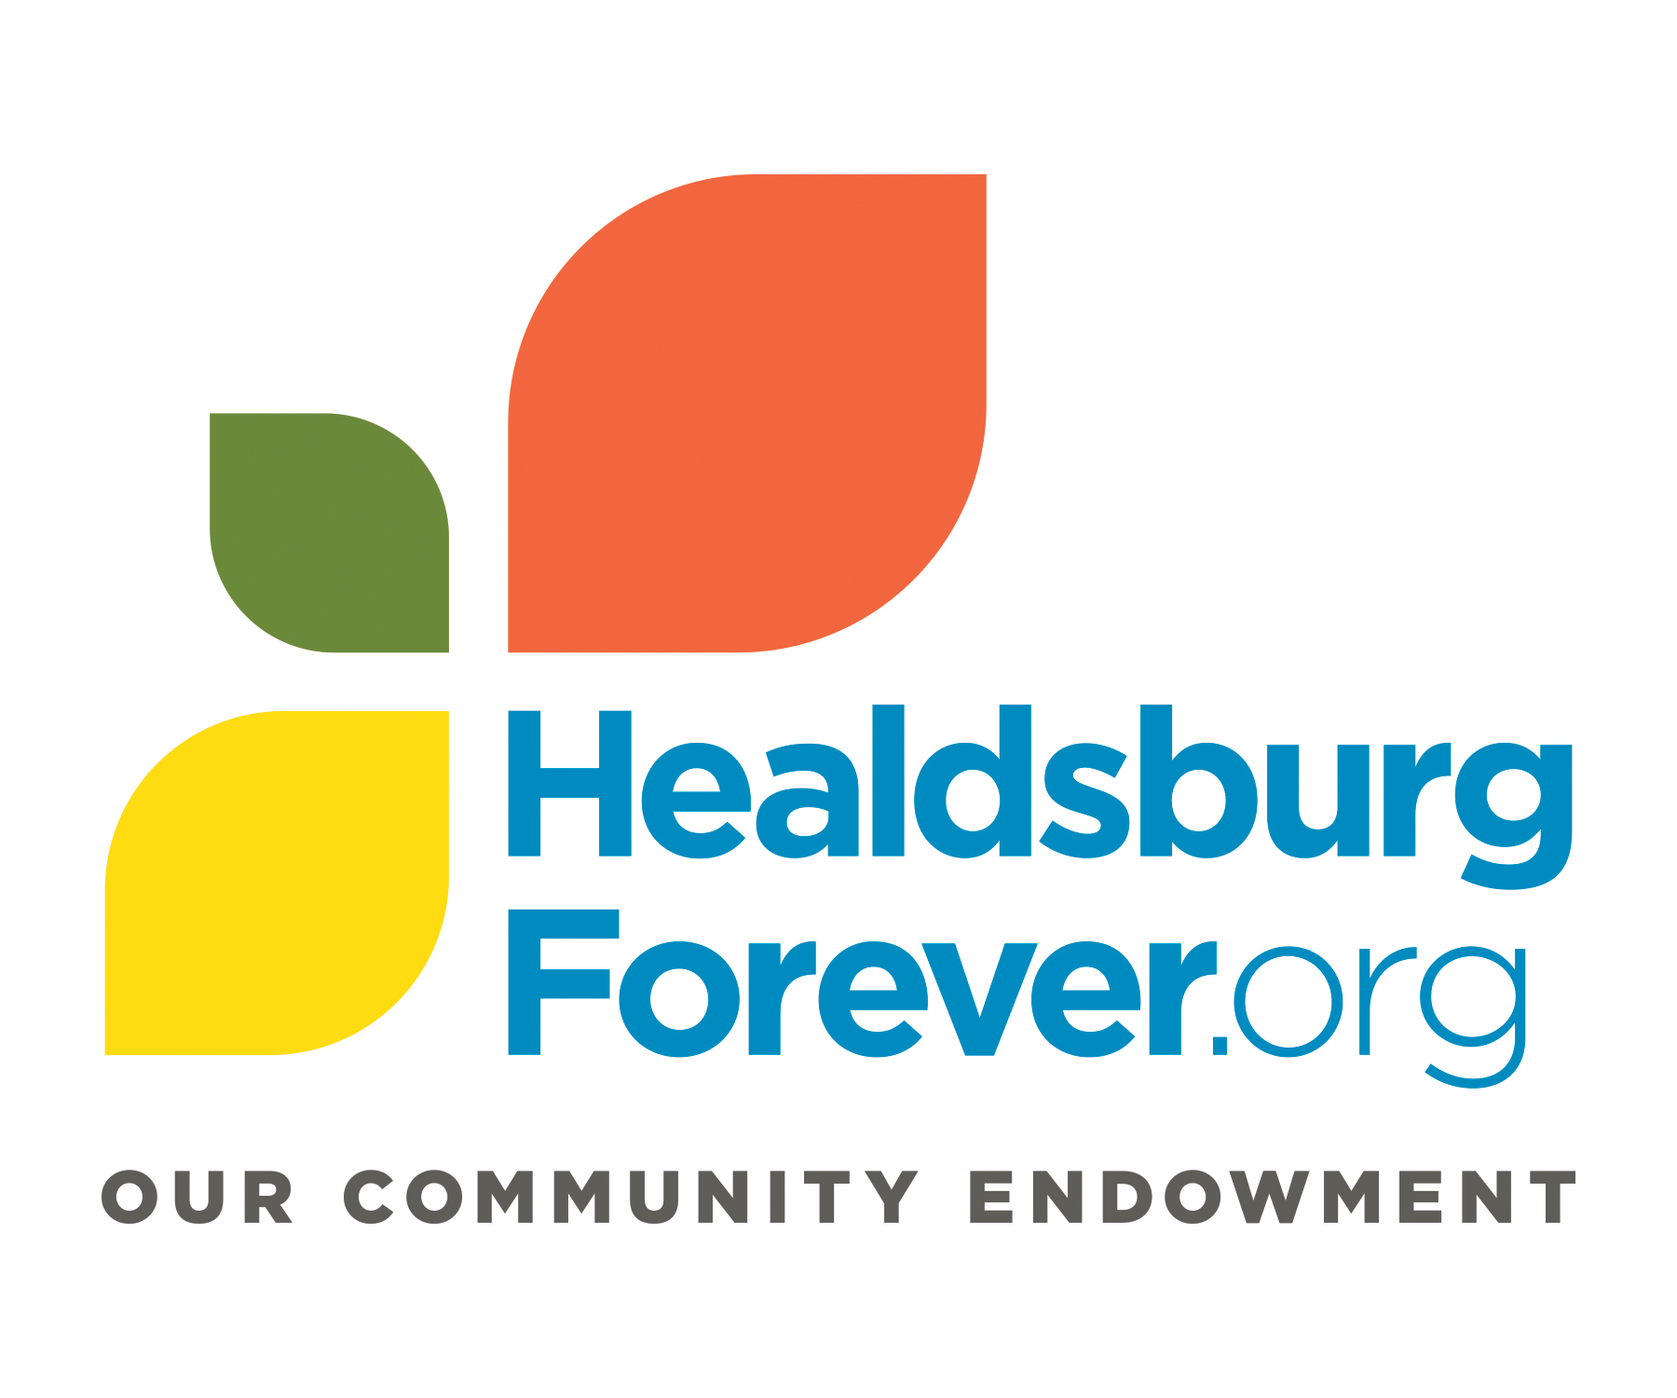
Community Foundation Sonoma County—Healdsburg Forever
2019 Grants Policy and Criteria

2019 Grants Policy
Grants will reflect the mission, vision, and values of the Healdsburg Forever Fund. Our vision is to ensure that the Healdsburg-Geyserville area is a sustainable, inclusive community in which all individuals have the opportunity to thrive.
1. Funding Priorities:
We accept grant applications in the following program areas:
A. Health & Human Services
B. Youth Development & Education
C. Arts Education
D. Environmental Education
We recognize the importance of supporting the social safety net as well as investing in education for the future of our community; at the same time we value the role of the environment and arts in creating and maintaining a vibrant community. Because of this, we will continue to emphasize grants in Health & Human Services and Youth Development & Education, but will seek to fund across the four program areas to support a sustainable and inclusive community.
We believe that the county-wide collective impact initiatives Health Action and Cradle to Career are important strategic efforts to strengthen communities. We will seek opportunities to align our grants in Health & Human Services and Youth Development & Education with these programs for maximum impact.
2. Types of Grants:
Health & Human Services and Youth Development & Education: Operational and programmatic requests up to $13,000
Arts Education & Environmental Education: Operational and programmatic requests up to $6,500.
The average grant award range is $5,000 to $10,000.

3. Evaluation Criteria
We recommend that non-profits that are considering applying for funding carefully review the criteria to evaluate whether their request is a fit for this funding. Please contact Ariana Díaz De León, adiazdeleon@sonomacf.org if you have questions.
General criteria for all grant applications:
- Specifically serves Healdsburg and/or Geyserville
- Organization has a clear statement of mission and goals
- Target population is either broad cross-section or an underserved segment
- Budget is realistic and aligned with the goals of the application
- Organization is stable and sustainable
- Organization demonstrates clear and measurable impact

Criteria specific to Health & Human Services and Education & Youth Development applicants:
- Request may be either programmatic or operational support
- Addresses a significant problem that affects the lives of individuals in our communities
- Meets our neighbors’ essential human needs for food, shelter, employment, health care and education
- Serves an underserved population
- Measures impact with clear tools and metrics

Criteria specific to Arts Education and Environmental Education applicants:
- Request may be either programmatic or operational support
- Provides direct arts/environmental education experiences
- Reduces barriers to participation, i.e., service hours, waiting lists, financial limitations, language/cultural differences, disabilities, geography, or transportation.
- Curriculum is delivered by qualified staff
- Provides multiple exposures to the curriculum (such as visits, lessons, or other engagement opportunities)
- Measures impact with clear tools and metrics

