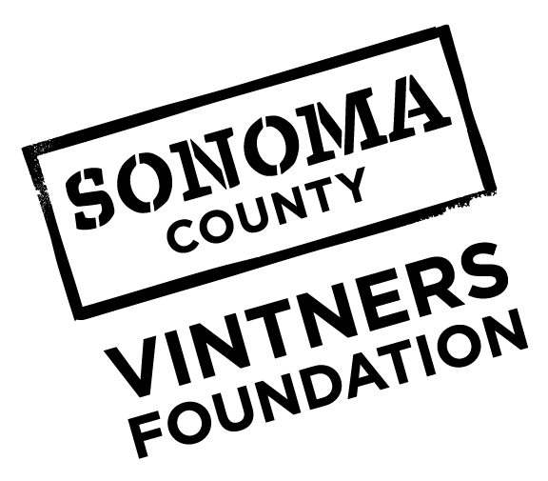
2018 Community Grants
Frequently Asked Questions

Funding Criteria and Priorities
What types of projects or programs are you prioritizing?
Sonoma County Vintners Foundation Community Grants is pleased to continue our commitment to four key program areas: Health and Human Services, Education, Environment and Arts and Culture. Applicants in any of the four areas will be considered only if the primary mission of the organization aligns with the stated funding priority.
Program Area | Funding Priority
Health and Human Services | Supporting the most fundamental needs around behavioral health, housing, homelessness, and hunger, funding will target organizations whose mission specifically addresses one of these three areas.
Education | Aligning with Cradle to Career Goal Area 3: “Every young adult is prepared for and completes the highest level of postsecondary education or training to achieve their career goals,” Community Grants funding for education will focus on programs or projects that provide opportunities for workplace, career and postsecondary learning for youth.
Arts & Culture | Knowing that access to arts education can foster a love of learning, improve personal dignity and enhance creativity, funding for the arts will focus on educational experiences for both youth and adults.
Environment | Recognizing the unique beauty and vulnerability of our natural resources, funding will target programs or projects that conserve and/or restore environmentally significant land, waterways and wildlife habitats.

What criteria will you use to make your decisions?
- The applicant’s organizational mission aligns with the Community Grants funding priorities
- The goals, implementation timeline and staffing are clearly defined and achievable
- Any proposed collaboration with other organizations has been formalized
Can current Fund the Future grantees also apply for Community Grants?
We are honored to provide significant support to our Fund the Future partners and seek to broaden our reach with the Community Grants program; therefore, we only accept applications from organizations that are current partners if the program or project is different than the Fund the Future program.

Do you prioritize organizations that are past grant recipients or do you prefer to fund organizations that are new to Sonoma County Vintners Foundation?
We are interested in funding new organizations and innovative projects in our community, and we value the partnerships we’ve already created with many organizations; we don’t prioritize one over the other. Please do keep in mind that being a former grantee does not guarantee future funding.

Funding
How will you distribute the funding among the four Program Areas?
We recognize that there are needs in all four Program Areas as outlined in our funding priorities. We will strive to align our funding allocations with an alignment to our criteria, in a broad geographic distribution with attention to all four areas.

What is the minimum and maximum amount of funding we can apply for?
There is no minimum; the maximum funding amount is $10,000.

Do you provide funding to sponsor events?
In some cases, yes, however, we do not sponsor events whose purpose includes fundraising.

Is there separate funding for Sonoma Valley?
No, there is one funding source for projects or programs throughout Sonoma County.

Is there a limit to the percentage of overhead that can be included in a project or program proposal?
There is not a specific limit to the percentage of administrative expenses that can be included in a proposal, however, we encourage you to select an amount that is reasonable to the project or program request.

If my nonprofit organization is based outside of Sonoma County, can I still apply for a grant?
Nonprofit organizations that have a significant presence in Sonoma County but are based outside of Sonoma County are eligible to apply.

How many applications can an organization submit? What if our organization has several departments that work independently?
In general our priority is to provide broad community-wide support, and prefer only one proposal from any one non-profit organization within a given grant cycle. However, if your organization is very large, with distinctly different programs, you may consider submitting more than one application.

Will it hurt my chances if I apply for the same program that I applied for last year?
We accept applications for the same project or program that you applied for last year. Generally speaking, if your application was declined it may indicate that the project or program was not a good fit for this funding.

Who reviews the grant applications?
We have a committee that will review proposals and make final funding decisions.

How do we apply for a Fund the Future grant?
Fund the Future is a separate, invitation-only grants program.

Can I apply to both a Sonoma County Vintners Foundation Community Grant and a Community Foundation Sonoma County grant?
Yes. These grant programs are separate and you may apply to both the Community Foundation and Sonoma County Vintners Foundation’s grant programs.

