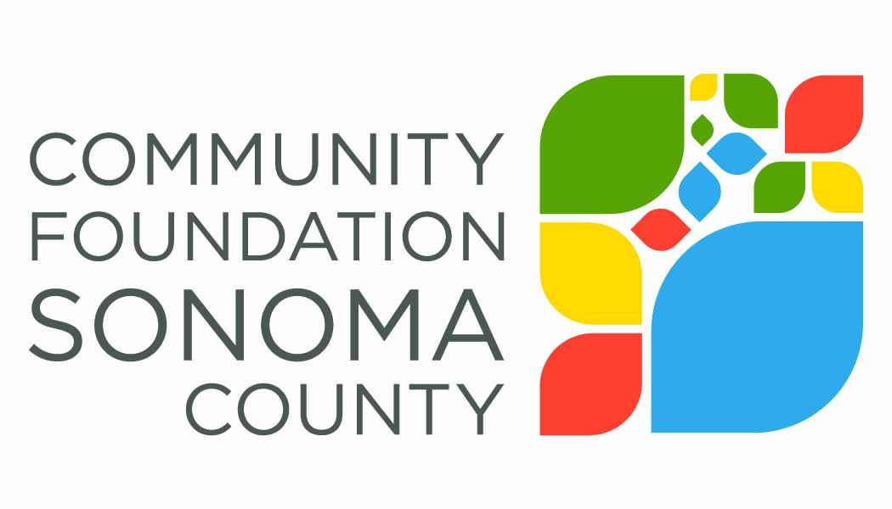
Contact Information for Funder Panel Participants:

Tipping Point
Karina Moreno
Chief of Staff
KMoreno@tippingpoint.org

North Bay Fire Relief Fund
Matthew Martin
VP Community & Government Relations
mmartin@redwoodcu.org

UndocuFund
Susan Shaw
Co-Director, North Bay Organizing Project
sshaw@northbayop.org

United Way of the Wine Country
Mike Kallhoff
President & CEO
Mike.Kallhoff@unitedwaywinecountry.org

Rebuild North Bay
Darius Anderson
Founder
info@rebuildnorthbay.org

Community Foundation Sonoma County
Elizabeth Brown
President & CEO
ebrown@sonomacf.org

