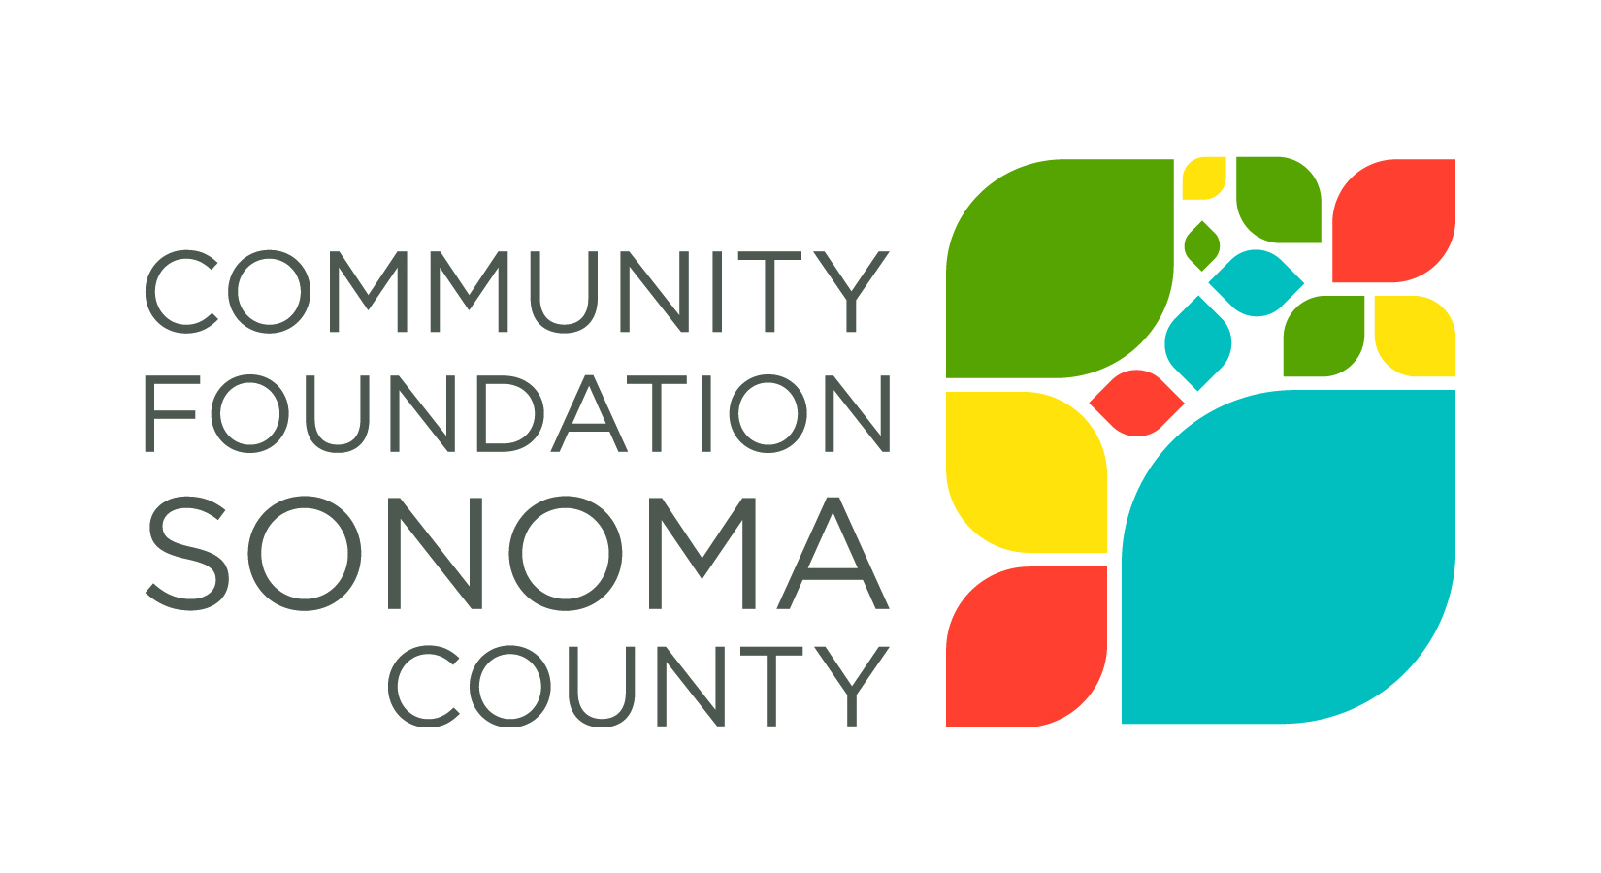
Community Foundation Sonoma County is interested in the impact our grant award has made on your organization and the community you serve. The grant report provides a structured process for reflecting on your work and a vehicle for describing impact to the community.
Report Instructions
Email your completed report as an attachment to grants@sonomacf.org. It is helpful to have a copy of the original Grant Application and Grant Contract on hand when drafting your responses.
2017 iREAD Final Grant Report
Grantee Organization Name:
Grant Number and Grant Amount:
Period Covered by this Report:
Organization Contact Person and Phone Number:
Date:
Please respond to the following. Refer to the proposal you originally submitted when answering specific questions about the program for which you applied. (Keep answers to approximately 200 words)
- Please describe specifically the goals you aimed to accomplish with this grant.

- What progress was made toward realizing these goals? If possible, discuss evidence of impact, e.g., number of clients served, demographic information, evaluation results, etc. Additionally, where possible please note the impact of the funding on increased reading to children by parents or other family members.

- What do you consider to be the greatest strength(s) of this program?

- Were there any disappointments in implementing your goals? If yes, please elaborate.

- Were there any grant funds that were not expended during the grant period? If so, what is the amount remaining? How will you utilize these funds?

- Were you able to leverage this grant to attract other funding?

- Please share any recommendations you have to enhance our grantmaking, grant application and/or reporting process.

- Please share a brief story about the impact this grant had on those you are serving.

