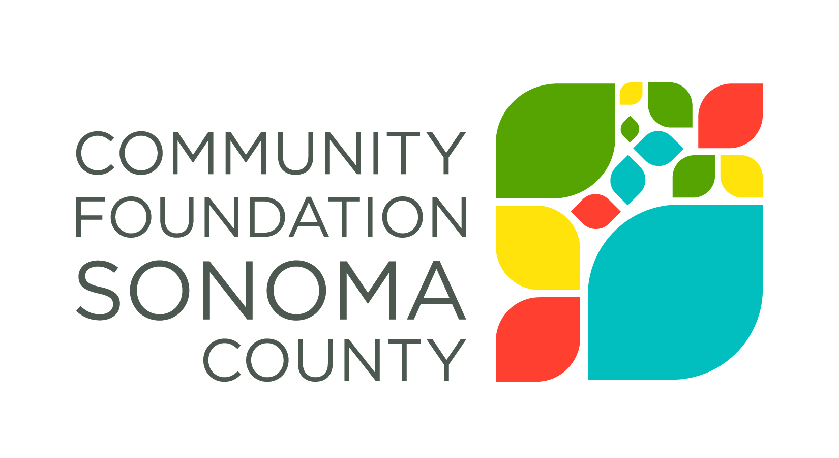
Community Foundation Sonoma County is interested in the impact our grant award has made on your organization and the community you serve. The grant report provides a structured process for reflecting on your work and a vehicle for describing impact to the community.
Report Instructions
Please email your completed report Annette Williams, awilliams@sonomacf.org. It is helpful to have a copy of the original Grant Application and Grant Contract on hand when drafting your responses.
2016-17 Homelessness Final Report
Grantee Organization Name:
Grant Number and Grant Amount:
Period Covered by this Report:
Organization Contact Person and Phone Number:
Date: (give the date the report is submitted)
Please respond to the following. Refer to the Grant Application when answering specific questions about the program for which you applied.
- Please describe specifically the goals you aimed to accomplish with this grant. This information should come directly from your original proposal.

- What progress was made toward realizing these goals? Where possible, please provide specific data such as the number of people served, demographic information, evaluation results, etc.

- Were there any unanticipated results, either positive or negative, that you have not yet described?

- What do you consider to be the greatest strength(s) of the program?

- Were there any grant funds that were not expended during the grant period? If so, what is the amount remaining?

- Please share a brief story about the impact the program had on an individual you served.

