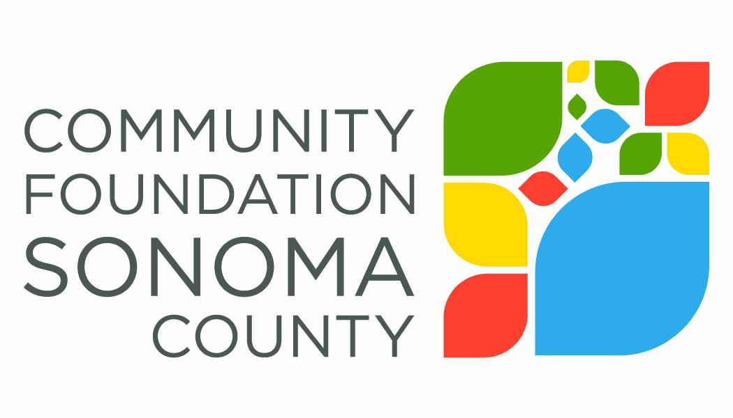
2017 iREAD Application Questions

- PROGRAM OVERVIEW:
  - The goal of iREAD is to increase the time parents and family members read to their children daily. Please describe how your program will meet that goal, including a clear description of the strategies you will use and how the iREAD materials and messages will be integrated.
  - How will you determine if your program is successful in meeting the goal of increasing daily reading?

- FAMILIES SERVED WITH THIS GRANT:
  - Please describe your targeted demographic for this program, and if the audience is new to you, your outreach plan.

- NEW OR EXISTING PROGRAM:
  - State whether your proposal is to enhance an existing program or for a new program.
  - If existing, how long have you operated the program? Please describe a recent success of the program.

- PROGRAM PLAN
  - Describe the sequence of steps that will be taken to implement your program and the timeframe in which this will occur.

- ABOUT YOUR ORGANIZATION:
  - Please describe the mission and three primary goals of your organization.
  - Describe the experience of key staff that will be implementing the proposed program.

- For current iREAD Grantees only:
  - Please describe specifically the goals you aimed to accomplish with support from your grant last year. What progress was made in reaching those goals? Where possible, describe the number of people served, demographic information, and specific measureable outcomes.

