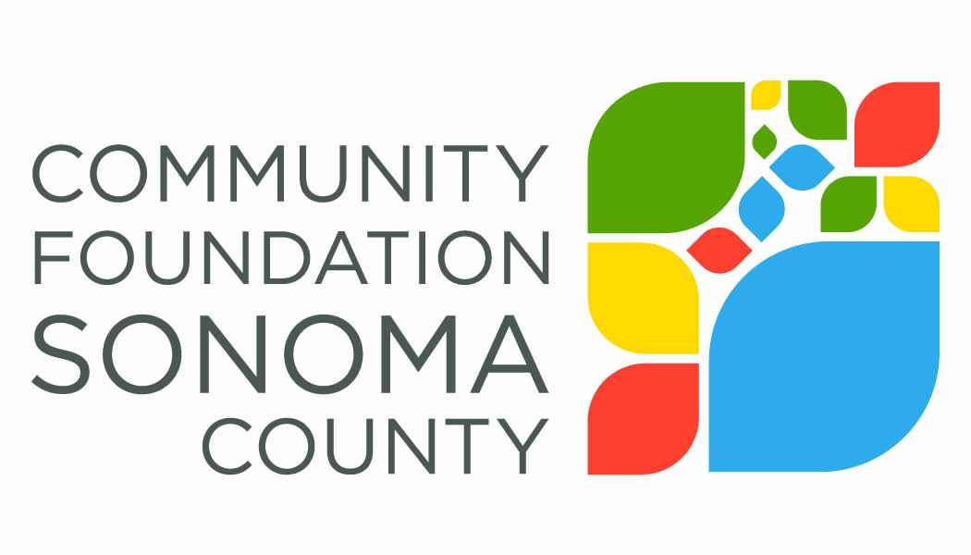
Community Foundation Sonoma County is interested in the impact our grant award has made on your organization and the community you serve. The grant report provides a structured process for reflecting on your work and a vehicle for describing impact to the community.
Report Instructions
Please email your completed report as an attachment to Annette Williams, awilliams@sonomacf.org by July 28, 2017. It is helpful to have a copy of the original Grant Application and Grant Contract on hand when drafting your responses.
2016-17 Arts Education Grant Report
Grantee Organization Name:
Grant Number and Grant Amount:
Period Covered by this Report:
Organization Contact Person and Phone Number:
Date: (give the date the report is submitted)
Please respond to the following. Refer to the grant application when answering specific questions about the program for which you applied. (Keep answers to approximately 200-300 words)
- Please describe specifically the arts education goals you aimed to accomplish with support from this grant. This information should come directly from your original proposal.

- What progress was made toward realizing these goals? Where possible, please provide specific data such as number of students served, demographic information, evaluation results, etc.

- What are you most proud of as a result of this grant?

- What was the greatest challenge related to implemented the goals of the grant?

- Were there any unanticipated results, either positive or negative, that you have not yet described?

- Were there any grant funds that were not expended during the grant period? If so, what is the amount remaining and what is your goal for expending the remaining funds?

- Please share a brief story about the impact this grant had on a student or teacher you worked with.

