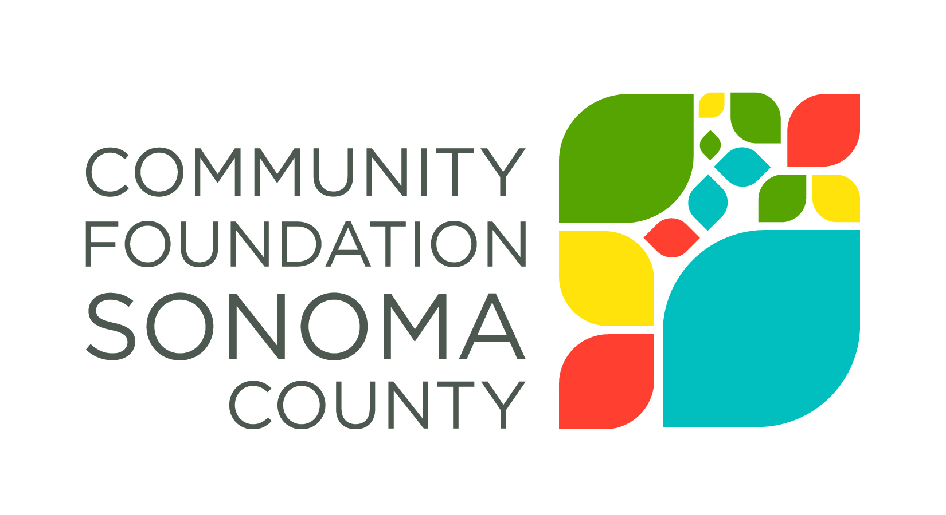
Sonoma Wine Country Weekend
Community Grants
2016

Interim and/or
Final Report Template

Sonoma Wine Country Weekend is interested in the impact our grant award has made on your organization and the community you serve. The grant report provides a structured process for reflecting on your work and a vehicle for describing impact to the community.
Report Instructions
Email your completed report as an attachment to grants@sonomacf.org no later than Friday, October 7, 2016. Please refer any questions to Annette Williams, Program Assistant, Community Foundation Sonoma County, awilliams@sonomacf.org, 707-303-9639.
Grantee Organization Name:
Grant Number and Grant Amount:
Period Covered by this Report:
Organization Contact Person and Phone Number:
Date Report is Submitted:
NOTE: If you have completed ALL the goals outlined in your grant application, you may submit this report as the final report. If you have not completed your goals, this report will be submitted as interim.
- Submit as Interim Report
- Submit as Final Report
Please respond to the following. Refer to the grant application that you originally submitted when answering specific questions about the program for which you applied. The entire report should not exceed 3 pages.
- Please describe specifically the goals you aimed to accomplish with support from this grant.

- What progress was made toward realizing the goals listed in Question 1? Where possible, describe the number of people served, demographic information, and specific measurable outcomes.

- Were there any unanticipated results, either positive or negative, that you have not yet described?

- What do you consider to be the greatest strength(s) of your program or project? Greatest challenge?

- Were there any grant funds that were not expended during the grant period? If so, what is the amount remaining?

- Please share a brief story about the impact this grant had on your organization and/or the people you serve.

